35.31: Destructive interference for 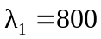nm incident light. Let be the refractive index of the oil. There is a 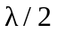 phase shift for the reflection at the air-oil interface but no phase shift for the reflection at the oil-water interface. Therefore, there is a net phase difference due to the reflections, and the condition for destructive interference is 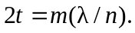 Smallest nonzero thickness means 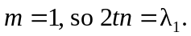
The condition for constructive interference with incident wavelength is 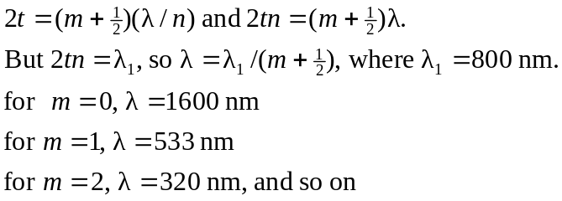
The visible wavelength for which there is constructive interference is 533 nm.

